****fcs_bar**

**Metcalfe County Family**

**and Consumer Sciences Newsletter**

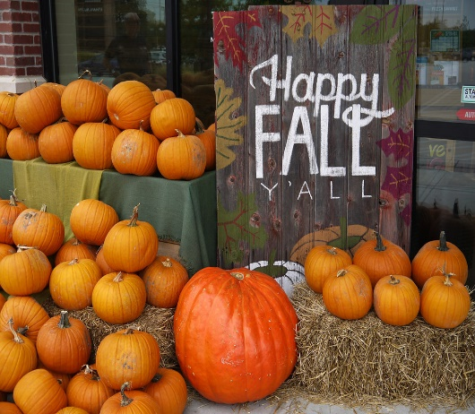

[This Photo](https://www.flickr.com/photos/sometimesong/29939259048) by Unknown Author is licensed under [CC BY-NC-ND](https://creativecommons.org/licenses/by-nc-nd/3.0/)

**September – October 2024 Calendar:**

**Tuesday September 10, 2024 – 9:00 a.m. Mammoth Cave Area Homemakers Cultural Arts Contest at the Warren County Cooperative Extension Service Office Bowling Green,** KY.

Bonnie Shaw, Metcalfe County Homemakers Association Cultural Arts Chair, has 1 item that qualified to be entered into the MCA Area Cultural Arts contest and if she chooses to enter it, can attend and judge a class that she does not have entries in, with another Metcalfe County Homemaker member. (Each participating County is asked to supply 2 judges).

|  |
| --- |
| **Cooperative Extension Service** |
| *Metcalfe County*  *422 East Street*  *Edmonton, KY 42129*  *(270) 432-3561*  *Fax: (270) 432-5087*  *www.ca.uky.edu/ces* |

**Thursday September 26, 2024,** **9:30 – 11 a.m. Tobacco Stick crafts and then at 11 – 12:30 Cake/cupcake decorating:** at the Warren County Extension office. The Multi-County Leader training for the October and November 2023 lessons**: While Lynn Blankenship will be away,** many MCAFCS Agents will be present to assist Nancy Doyle and Laura Grace Vincent in presenting these hands-on leader trainings. **No Lunch or refreshment are included.**

**Tuesday October 1st, 2024:**

9:30 – 11 a.m. Tobacco Stick crafts **and then at** 11 – 12:30 Cake/cupcake decorating The Multi-County Leader training for the October and November 2023 lessons, **at the Barren County Cooperative Extension Service office**

**Note on the above leader trainings:**

The lesson leaders for each club for October and November 2024 leader trainings, *were contacted in August by Marla Young and asked which location they planned to attend*. **An RSVP was provided to the contact Agents letting them know which location you said you would participate at**. If this changes, please let Marla Young know ASAP, so the correct Agents can be notified.

There is a box of materials that will need to be picked up at the Extension office prior to attending the leader training in either Barren or Warren Counties, by 1 homemaker leader to USE at the Multi- County leader training. It will need to be brought back to the Extension office after the leaders attend their training as it has Metcalfe Co. supplies **that the clubs will also be able to borrow for when they teach the club lesson.**

**Thursday October 17, 2024: Mammoth Cave Area Extension** HOMEMAKERS’ Association Annual Meeting **“Bring Your Heart to Hart County!”** Will occur at the Munfordville Baptist Church @ 501 N. West St., Munfordville, KY, **beginning at 9:00 a.m.**

The MCA Annual Day meeting attendance registration form is enclosed, **cost is $20.00 per person, if you would like to attend:**

1. **BY or before 3:30 p.m. 9/20/24, please drop off your $20.00 fee and completed registration form,** to the Metcalfe Co. Extension office Betsy or Marla, **checks made payable to Metcalfe Co. Homemakers Assoc.**

****

**PLEASE Donate non-perishable food items for the Blessing Boxes in Hart County -- for the 2024 MCA Annual Day Service Project, sponsored by Hart County Homemakers, the 2024 Area Annual day meeting Host.**

**EVEN If you cannot attend this MCA Homemakers Area Annual Day meeting, consider donating some cereal or canned goods, to support the Homemaker’s work with the Blessing boxes in Hart Co.** Lynn has a black and white large 31 bag in her office, for members to drop off donations to.

**Thursday October 24, 2024**: **Homemakers Annual Homemade Soup Luncheon and Silent auction,** 10:00 a.m. until sell – out, *usually over by 2:00 p.m.* Ovarian Cancer screening and Homemakers Scholarship fundraiser, at the Metcalfe County Extension office back meeting room. Clubs will discuss food/volunteer needs/roles, at the September Club meetings.

**Starting at 9:00 a.m. We will need volunteers the day of, at the Extension office:**

* 1 – 2 to take fees and sign in sheets by the entry,
* 2 to fill/clean/maintain the garnish/cornbread and dessert tables.
* 2 to serve soups.
* 2 to work the kitchen, bring out more cornbread and soups and offer breaks to staff working the soups/backroom room/tables, etc.

**SILENT AUCTION:**

All members are asked to donate new items *if body products, or candles (please do not donate previously opened skincare/body products, candles that have been lit etc.) Cakes, homemade candies, g***ently used items such as books, art, crafts, jewelry, white elephant, etc., are perfect to donate.**

WE very much appreciate your support however you are able to offer it – if you do not have items to donate and cannot assist with food preparation or working the event, please bring a friend, come and eat and bid on the silent auction items donated. Also please help to promote this event, to your coworkers, church family etc.…

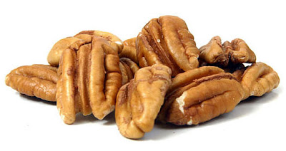**’24 PECAN SALE**

Pecans for 2024 **are $ 10.75/bag** and will be ordered for the County, Tuesday October 15th.



Club members and members at large, **please turn your pecan orders in:**

1. **CLUB MEMBERS - to your club president no later than 10/11 2024.**

1. **IF A MAILBOX MEMBER, turn into the Extension office no later than 10/14/24.**

**Updated member order forms with complete instructions are included in this mailing, for you to use.**

**Pecans usually arrive well prior to Thanksgiving.**

**Are you diagnosed as Diabetic?**

**If yes, you may qualify to participate in a paid study that provides you with FREE one-to-one consultation with a dietician in your home or location of your choosing. Please see the enclosed flyer for details. If you are not Diabetic but know someone who is, please share this flyer with them.**

Thank You ALL!

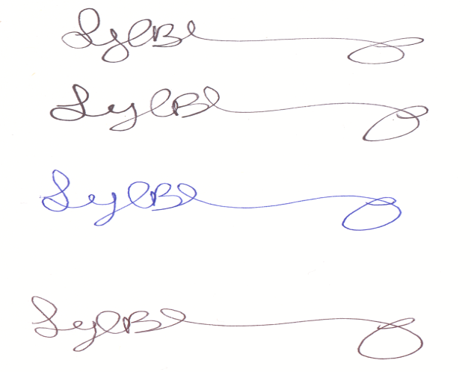

\_\_\_\_\_\_\_\_\_\_\_\_\_\_\_\_\_\_\_

Lynn A. Blankenship,

Metcalfe County Extension Agent

For Family & Consumer Science Education